Configuration

- Purpose

The configuration menu will be used to define lookup data for all the form views in EPFC Loan module. This menu is subdivided into the following groups:

- Financing
- Accounting
- Localization
- MC Registration
- Config Logs
- Credit Investigation Questions
- Branch Information
- Vehicle Information
- Documentation
- Others
- Reports

- Financing
- Localization
- MC Registration
- Config Logs
- Credit Investigation Questions
- Branch Information
- Vehicle Information
- Documentation
- Others

  - List View
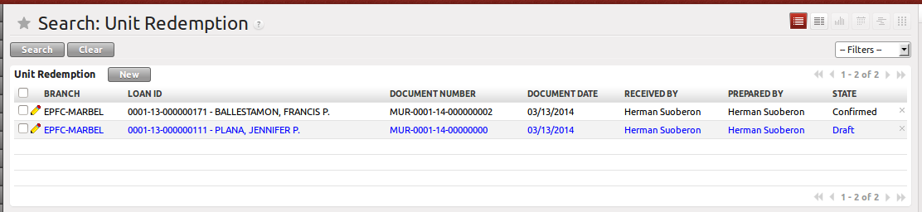
Figure 1. List view of MC Unit Redemption

  - Form View
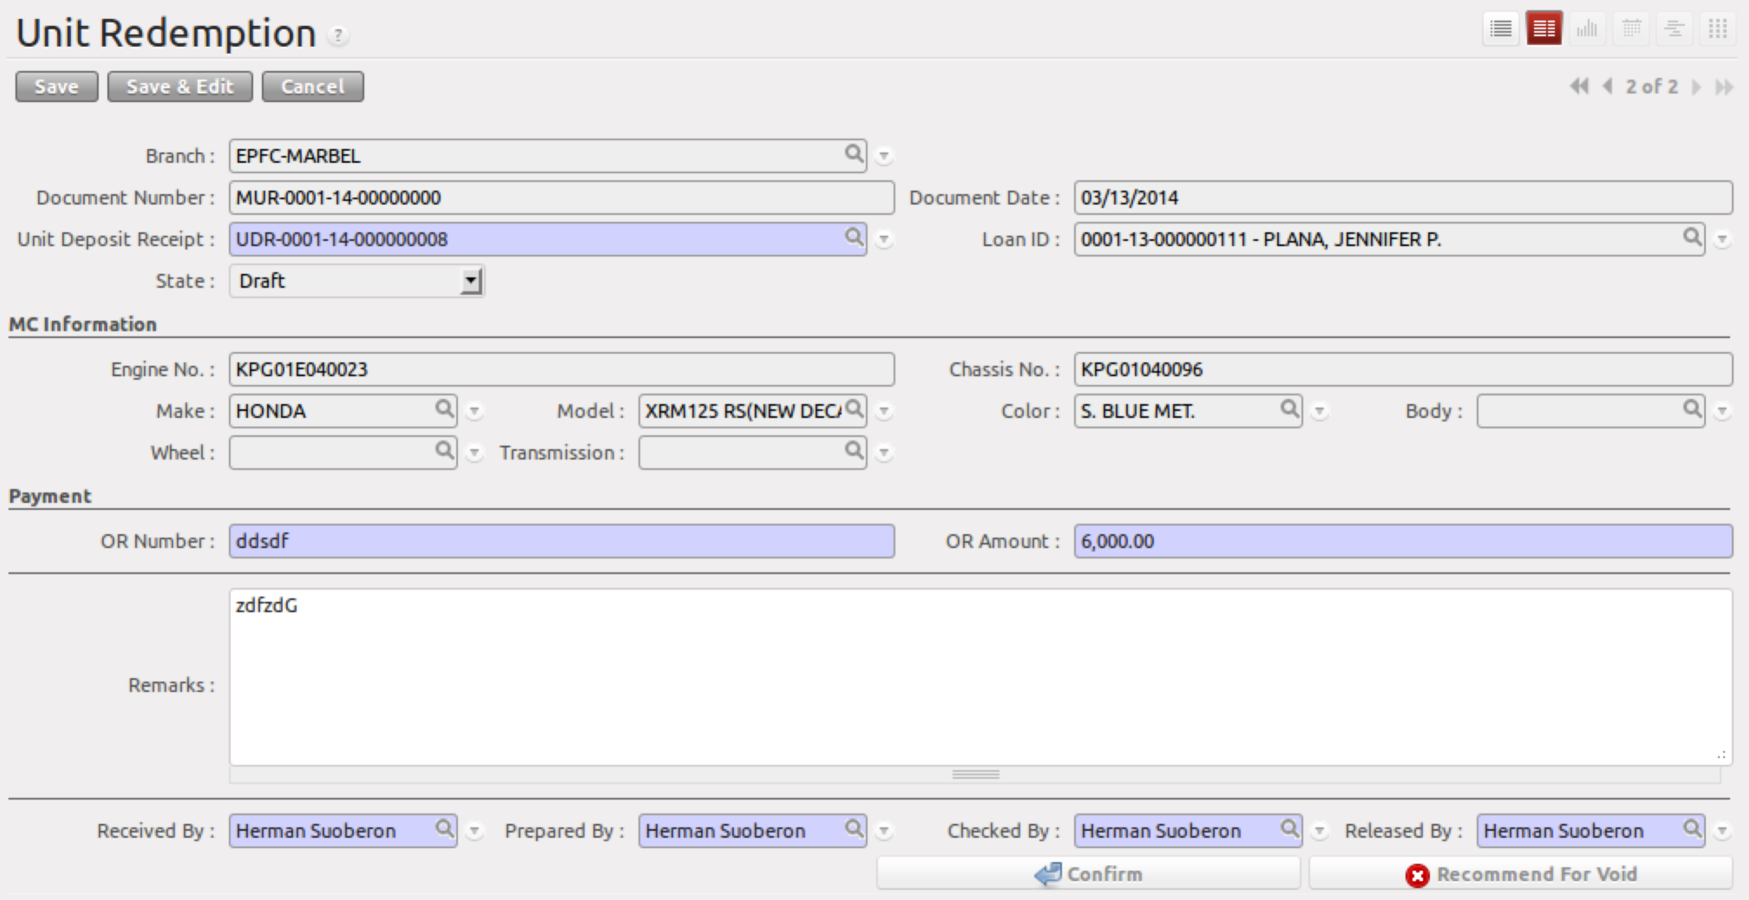
Figure 2. Form view of MC Unit Redemption

- Menu and Access Rights
  - Menu – Loan > MC Unit Redemption
  - Access Rights
Role | Read | Write | Create | Delete
Receptionist | Yes | Yes | Yes | No
CI/Collector | Yes | Yes | No | No
Branch Manager | Yes | Yes | No | No

- Required Fields
All required fields can be easily distinguished from the form view. These are the fields highlighted in Figure 2.

- Unit Deposit Receipt – the UDR of the customer where status is “Confirmed”
- OR Number – receipt number used to settle the account of the customer
- OR Date – date of receipt
- Received By – name of customer.
- Prepared By – name of receptionist
- Checked By – name of the branch manager who confirmed the unit redemption
- Released By – name of the guard who released the unit

- Workflow
Below is the list of states and visibility of the various buttons based on the record state:

State | Description | Visible Buttons
Draft | Initial state of the Unit Redemption record | Confirm  Recommend for Void
Confirm | Confirms the Unit Redemption record | Recommend for Void
Draft/Confirm - Recommend | UR was recommended for void by the Branch Accounting Assistant. | Veto Void Recommendation  Void
Void | Cancels UR | N/A
Veto Void Recommendation | Cancels Recommendation for Void | Recommend for Void  Confirm

- User Action
Below is the list of user action available for specific users and its corresponding procedures:

Button | Action | Triggered By
Confirm | - Creates a draft record in Asset Transfer Slip  - Updates the state of UDR to “Redeemed” | Receptionist
Recommend for Void | No Action | Accounting Assistant
Void | - Voids the draft record in Asset Transfer Slip | Branch Manager
Veto Void Recommendation | No Action | Accounting Assistant
Set Back to Draft* | Only allow this action when Asset Transfer Slip is still in ‘Draft’ state | Accounting Assistant  Accounting Assistant 2  Branch Manager
*for finalization

- Field Visibility
Below is the list of fields and their accessibility based on the record state:

Field | Description | Editable States
Unit Deposit Receipt | Existing Unit Deposit Receipt | Draft
OR Number | OR used to settle the defaulted account | Draft
OR Date | Date of OR | Draft
Received By | Customer Name | Draft
Prepared By | Name of Receptionist | Draft
Checked By | Name of Manager | Draft
Released By | Name of Guard on Duty | Draft

- Reports and Print Outs
